Fog and turbulence interactions in the marine atmosphere (Fatima) – Year 5 Review
(https://efmlab.nd.edu/research/Fatima/)

Dates: June 11 & June 12, 2026 (Thursday and Friday)
Venue: Cushing Hall, Room 303 (see attached map)
Zoom Link (both days): https://notredame.zoom.us/j/94372961274
Meeting ID: 943 7296 1274
One tap mobile
+13017158592,,94372961274# US (Washington DC)
+13052241968,,94372961274# US
by SIP - 94372961274@zoomcrc.com
Host: University of Notre Dame (POC: Joe Fernando, Cell 574-309-2345)
Main Hotel: Fairfield by Marriott Inn & Suites, 1220 East Angela Boulevard, South Bend Indiana, 46617) (Phone: 574-234-5510) – Breakfast Provided.
Transportation and Events:
Walking distance from the hotel to the conference venue
Breakfast and Lunches:
Conference Lunches – will be served 12:45 to 1:45 pm Thursday and Friday
Conference Breakfast – will be served from 07:30 to 8:30 am, Thursday and Friday
Dinner:
At Joe Fernando’s Residence, 07:00 pm. Transportation can be arranged, if needed (Please liaise with Mathis Chabert D’Hieres at the meeting)
Address: 51483 Megan Court, Granger, IN 46530
Workshop Program
Thursday 11 June, 2026
Time | Speaker | Title
Chair | Joe Fernando | Opening Session
08:30– 08:40 | Dr. Mark McCready  Associate Dean of Engineering, Research, UND | Welcome Remarks
08:40 – 08:50 | Dr. Dan Eleuterio, ONR | ONR Perspective of Marine Fog Research
08:50 – 09:00 | Dr. Anna Wilson, ONR | ONR Remarks, and future opportunities
Chair | Qing Wang, NPS | ~ 30 min talks
09:00 – 09:30 | H.J.S. Fernando, UND | Fatima: An Overall Progress Report & Year 5 Progress at UND
09:30 – 10.00 | KI Chang, GeoSR, Republic of Korea (ROK) | ROK Contributions to the Fatima-YS Program  (and, a Brief ROK Prospects of MARBLES)
10:00 – 10:30 | Clive Dorman, Scripps | Synoptic Contributions to the Fog Genesis
 |  | (+ comments by Clive Dorman on AMS Special Issue)
10:30 – 10:50 | Break
Chair | Clive Dorman | 30 min talks
10:50 – 11:20 | Qing Wang, NPS | Understanding air-sea interaction and fog over the ocean - results from Fatima
11:20 – 11:50 | Eric Pardyjak, UU | Summary of Fatima findings related to understanding DSDs, turbulence during fog, and low-cost LWC observations
11:50 – 12:20 | Lian Shen, UM  (With Anup Barve) | Study of FATIMA Campaigns Through the Lens of Multi-Scale Coupled Simulations.
12:20 – 12:45 | Darko Koracin (25 mins) | The marine boundary layer, clouds, and fog over the NW Atlantic, Canadian Shelf and Grand Banks revealed by the research vessel Atlantic Condor
12:45 – 01:45 | Lunch
Chair | Eric Pardyjak | 25 min talks
01:45 – 02:15 | David Richter (UND) | Turbulence-microphysics interaction in marine fog: Results from droplet-resolved LES
02:15 – 02:40 | Luc Lenain (Scripps) | Investigation of Turbulence and the Fog Life-Cycle: From Micro-Physical Structure to Large Scale Dynamics
02:40 – 03:05 | Anne Dowling (UND)) | Formation of Cold Patches in Coastal Yellow Sea: A precursor for fog genesis
03:05 – 03:40 | Eren Gultepe (Univ Southern Illinois) | Open-Loop Generative AI Nowcasting of Dense Marine Fog: Application of Fatima data
03:40 – 04:05 | Carl Schmidt (U. Alaska) | Near Surface Microphysics: Implications for Boundary Layer Conditions
04:05 – 04:25 | Break
04:25 – 04:50 | Marylyn Dunbar (AFIT) | Optical Extinction and Modeling Radiative Properties with LEEDR of Fog Events in North Slope Alaska
04:50 – 05:15 | Baban Nagare (UND) | Some Aspects of Ice-Fog Microphysics
05:15 – 05:40 | Edward Creegan (ARL) | An Overview of Fatima-GB and Fatima-YS R/V Ops
07:00 | Workshop Dinner | At Fernando residence (see above)

Friday 12 June, 2026
Time | Speaker | Title
Chair | Edward Creegan (ARL, White Sands) | 25 min talks, Zoom Session
08:30 – 08:55 | Reneta Dimitrova (UND and University of Sofia) | Fog Genesis during the Evening Transition in the Fatima-GB Campaign at Sable Island: Insights from WRF-LES Studies
08:55 – 09:20 | Jung-Hoon Kim  (Seoul National University) | Numerical Simulation of a sea fog event over Eastern Yellow Sea with a transition of air-sea temperature difference (and notes on recent US-Korea Collaborative Research Initiative Following Fatima)
09:20 – 09:45 | Ismail Gultepe, UND/OnTech | A Review of FATIMA Fog Microphysics; Successes and Challenges
09:45 – 10:10 | Gianina Giacosa (with Rachel Chang), Dalhousie U | Aerosol and Droplet Microphysics during FATIMA-YS
10:10 – 10:35 | Trevor VandenBour (York) | Microphysical chemistry of fog-aerosol interactions during Fatima-GB and new observations from YS
10:35 – 11:00 | Peter Taylor (York) | Case Studies of Fog on Sable Island Using the Weather Research and Forecasting (WRF) Model
11:00 – 11:25 | Patrick Conry (Honeywell Inc) | Fog: Science to Technology Transitions
11:25 - 12:00 | Matthis Chabert d’Hieres | Fatima-IF Study (in-person)
12:00 – 1:00 | Lunch Break
Chair | Joe Fernando
01:00 – 01:30 | Advisory Committee Comments | Zoom
01:30 – 01:45 | Final Remarks | Joe Fernando
01:45 – 02:00 | Final Remarks | Ana Wilson (ONR)
Lab Tour for those interested.
Scott Coppersmith will lead it

Map and Instructions:
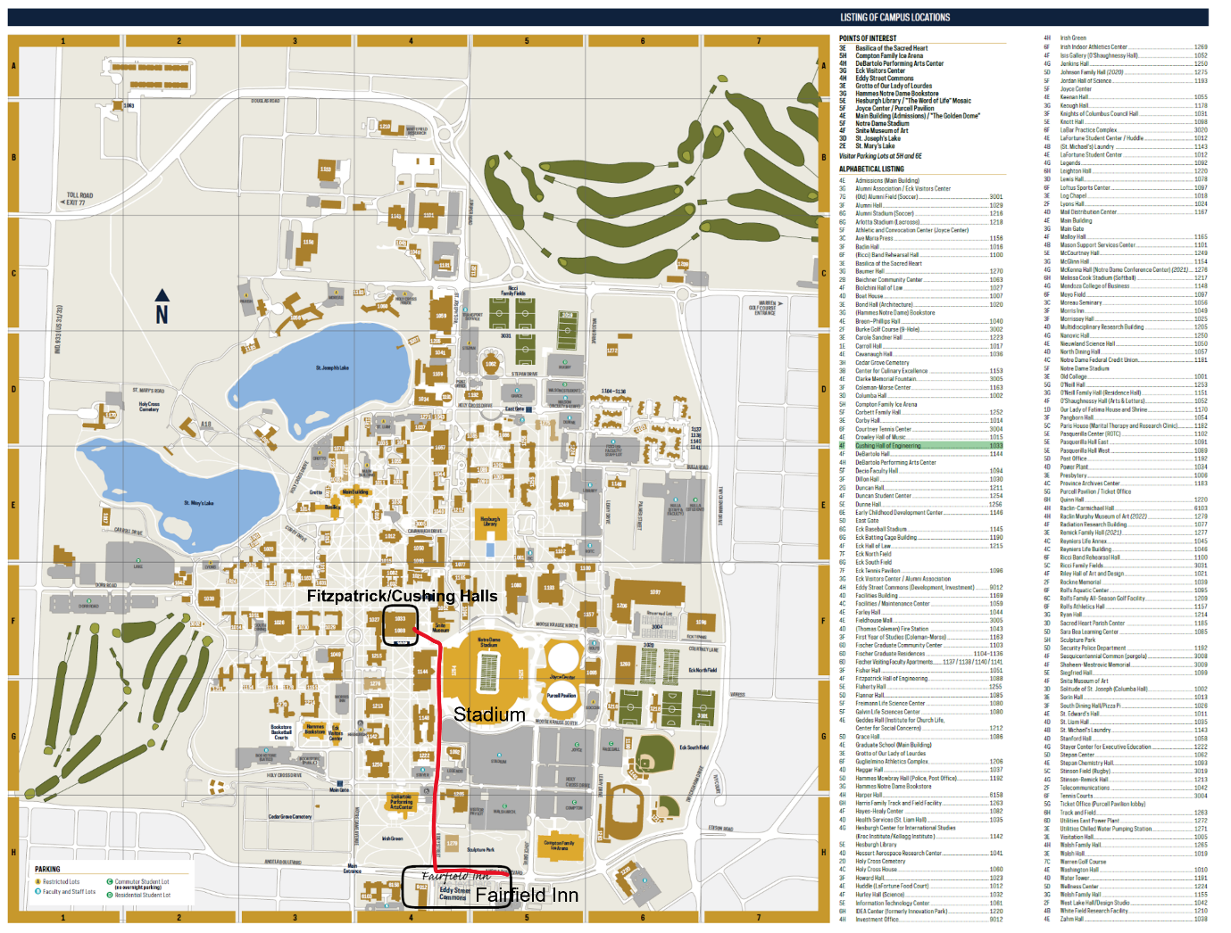
To get to Cushing Hall 303:

- Enter the doors to Fitzpatrick Hall which is diagonal from the stadium (See the picture of entrance; If construction is ongoing, please maneuver around it).  - Take the elevator to the third floor.  - Walk all the way straight down the hall from the elevator and turn left at the stairs.  - Cushing Hall 303 will be the lecture hall on the right | 