Advisory Committee Comments at the Fatima In-Person Meeting, 8-9 December 2021.
JD:
Impressive set of talks and plans
Not only the physical processes but also how they interact need to be studied. That is, scale interactions. This is a very important thing for modeling. Make sure that you capture them, without compromising the big goals.
Think ahead how observations can be used to constraint the models, in addition to parameterizations
Come up with a one-page white paper on how we overcome knowledge gaps, and how LES/DNS/Observations can be used to address them
-------------
AH:
Instruments should be very carefully calibrated before and after each field campaign (AH).
Could you use your retrieval algorithm (e.g. Igel’s talk) to get fog coverage in the FATIMA region by month and over as many years as possible to characterize fog coverage by year. It could be an interesting way to look at the association of fog to climate change.
How do non-activated aerosols within fog affect fog optical depth (AH).
CINCS instrument. Is the ice supersaturation very high in the inlet? IN activation are very sensitive to the ice supersaturation
Ismail showed a plot of Z_{e} vs Extinction. What was the radar wavelength? Let’s derive a Z_{e} vs Extinction relationship using the W band radar measurements. Do this for a variety of conditions. Can we relate Lidar extinction measurements to extinction? Lidar will be available on Sable Island. If radar or lidar is available, mitigates the nighttime visibility problem.
I think we could do a lot to understand turbulence in the Fatima clouds over a wide range of horizontal and vertical distances, in addition to the turbulence measurements from Sable Islands
I suggested earlier that we use chaff to track vertical motions and turbulence/turbulent scales. The basic idea would be to track the chaff and from that derive the vertical motions, and the scale of the vertical motions.
Platforms for Dispersing Chaff: UAV; Tower; Gondola on ship; Tethered balloon
Instruments for observing Chaffs: W band radar; Lidar

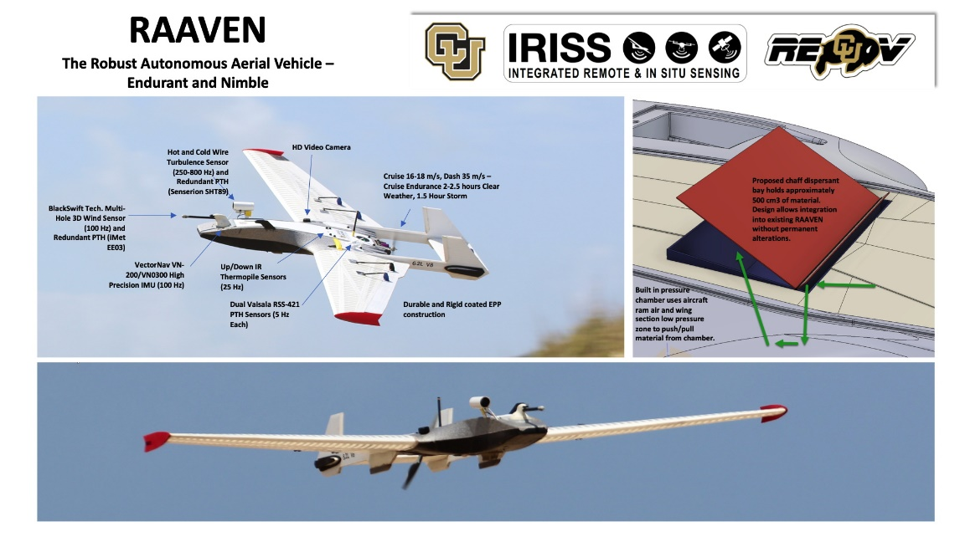

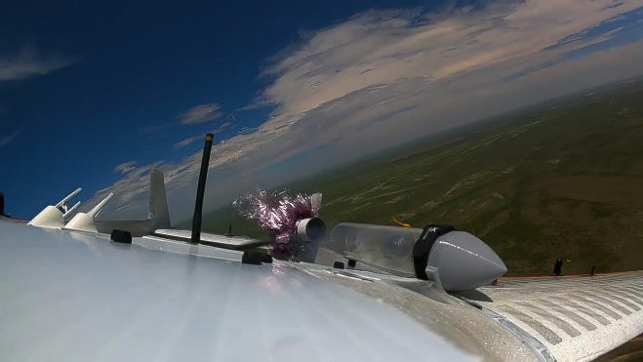 | 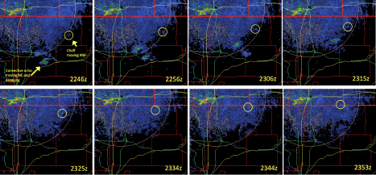

-------------------
MW:
Delve into path weighted and local optical measurements, how are they related, statistical variations of these relations
Fielding low power systems to measure fog and turbulence. Can we try to develop these capabilities.
Differential measurements of temperature and other properties along the fog paths of interest, especially for work at Dahlgren. How these differential properties determine fog nonlinearities.
--------------
PT:
Impressive talents and instruments
High fog intensities and high frequency fog along the continental shelf is intriguing. Must be studied to see Why?
Vertical variation of properties (liquid water content, microphysical quantities etc are attempted in Fatima, which should be pursued unhesitant way
Near the ground, droplet sinks are unknown. How to represent them? vertical variation of droplets near the ground/ocean surface is very important.
Emphasis on IBL is good to hear. Will be important in ocean-land interface at the Sable Island.
Ideas on bi-modal distribution of fog and its relation to aerosol properties (biological and chemical) should be pursued. Make sure we have sufficient bio and chemical characterizations.

